Check Mail

**Create a new project called ControlStructures. Inside this project, create two new classes: CheckMail.java and Cashier.java.**

The U.S. post office has rules about mailing boxes. A box cannot be mailed first class if:

* The sum of its length and circumference is greater than 100 inches
* If the box weighs more than 70 pounds

*The circumference is the perimeter around the height and width, where the length is defined as the longest of the three dimensions.*

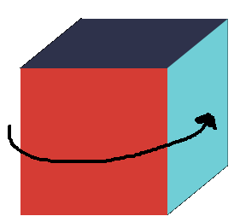

**CheckMail Methods**

**Method 1. Check Largest problem**

public void findLength()

|  |
| --- |
| **Psuedocode - More detailed pseudocode version:**  Determine longest of three dimensions  **Detailed psuedocode - Determining longest of three dimensions:**  Use three variables, called dim1, dim2, and dim3. Try to end up with dim1 holding the largest value.  Compare dim2 and dim1, if dim2 is greater, swap dim1 and dim2, dim1 will be holding largest value.  Compare dim3 and dim1, if dim3 is greater, swap dim1 and dim3, dim1 is still holding largest value. |

The method should determine the longest dimension of the box, and then print out like the following:

**Length =** 50

**Other two dimensions** = 10 20

**Weight =** 30 **lbs**

**Method 2. Calculate Circumference problem**

public boolean calcCirc()

The method should calculate the circumference, and return true if the box is too big (the sum of the circumference and the sum is greater than 100 inches) and return false if it is fine.

**Method 3. Calculate Weight problem**

public boolean calcWeight()

The method should return true if the box is too big (the weight is larger than 70) and return false if it is fine.

**Method 4. Output**

public String output()

The output method uses the above methods to check to see if a box is able to be mailed. The following are the possible output messages to be returned:

1. Box is too large and too heavy.
2. Box is too large.

3. Box is too heavy.

4. Box is acceptable.

**Cashier Methods**

Main Method

Using your method, test the following to and format your output like the following:

|  |
| --- |
| Length = 50  Other two dimensions = 10 20  Weight = 80 lbs  Box is – too large and too heavy |
| Length = 50  Other two dimensions = 10 20  Weight = 30 lbs  Box is – too large |
| Length = 50  Other two dimensions = 50 90  Weight = 100 lbs  Box is – too large and too heavy |